Polymorphism

Workshop #5

Flutter Developer Bootcamp

# **Purpose**

This workshop demonstrates inheritance and method overriding in object-oriented programming using Dart.aims to teach the basics of inheritance, method overriding, and polymorphism using Dart, providing foundational knowledge for developing more complex object-oriented Dart applications.

**Problem**

In the given workshop demonstrates inheritance and method overriding in object-oriented programming. It defines a Car class with a driving() method that prints "driving car A". The Honda class extends Car, overriding driving() to call super.driving(), effectively printing the same message. In main(), an instance of Honda invokes its overridden driving() method, demonstrating how subclasses can customize inherited behavior while leveraging functionality from their superclass.. You need to defines a Car class with a driving() method that prints "driving car B".

**How to Solve**

1. Checkout the workshop from Git Repo:

git clone -b <user-branch> <repo-URL>

1. Open the root folder inside VS Code
2. Open the root folder in terminal
3. Run the command dart run filename.dart
4. Car Class: Defines a class Car with a method driving() that prints "driving car A".
5. Honda Class (Subclass of Car): Extends Car, overrides driving() to call super.driving(), which prints "driving car A".
6. Main Function: Creates an instance carA of type Honda, calls carA.driving() to execute the overridden driving() method..
7. Honda Class (Subclass of Car): Extends Car, overrides driving() to call super.driving(), which prints "driving car B".
8. Go To File: <specific-file--method> à <method-name>, implement your logic.

**You will Achieve**

When you complete this workshop you will learn the following:

**Methods and Functions Used:**

* **Car Class (Car):**
* void driving(): Prints "driving car A" to the console.
* **Honda Class (Honda - Subclass of Car):**
* @override void driving(): Overrides the driving() method inherited from Car. Calls super.driving() to invoke the superclass's method, printing "driving car A".
* **Main Function (main()):**
* main(): Entry point of the Dart program.
* Creates an instance carA of type Honda.
* Calls carA.driving() to demonstrate method overriding. This executes the overridden driving() method in Honda, which in turn invokes super.driving() from Car.

# **Screenshots**

## **Before implementation (without printing diving car B)**

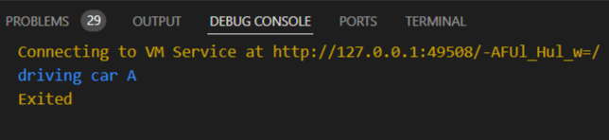

## **After implementation (with printing driving car B)**

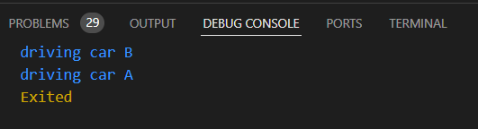

# **How to submit your workshop**

Push your project back to the same git branch using command:

<command name>

# **Happy Coding!**